[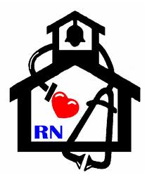](http://www.google.com/url?sa=i&rct=j&q=&esrc=s&frm=1&source=images&cd=&cad=rja&docid=dyXkjpQhp5ShHM&tbnid=jBVsIT9YeoKk7M:&ved=0CAUQjRw&url=http://www.dcs.k12.oh.us/site/Default.aspx?PageID=371&ei=6hcvUrSSFIna8wSY-ICwBg&bvm=bv.51773540,d.eWU&psig=AFQjCNG-BO4QJ-py6cplfZ-oBAeKnmDwqA&ust=1378904351425923)

**Nurse’s Nook**

**Pearl Lower Elementary – March**

**Aly Weems, School Nurse**

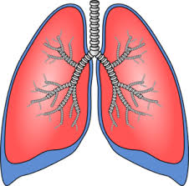 **What are the benefits of quitting smoking? C:\Users\atweems\AppData\Local\Microsoft\Windows\Temporary Internet Files\Content.IE5\VMTPBUCK\MC900290958[1].wmf**

Many smokers think that because they have smoked for so long the damage has been done and

it is too late to quit. This is not true. All smokers, no matter how heavily they smoke, will notice

significant benefits after quitting smoking.

These are some of the benefits of quitting and how soon they could happen after you quit:

|  |  |
| --- | --- |
| **Immediately** | The air around you and your family and friends is safer. |
| **Within 20 minutes of your last cigarette** | Your heart rate and blood pressure drop. |
| **Within 12 hours** | Carbon monoxide in blood drops to normal level. Oxygen in blood increases. |
| **2 weeks to 3 months** | Your circulation improves and lung function increase. |
| **1 to 9 months** | Coughing and shortness of breath decrease. |
| **1 year** | The excess risk of coronary heart disease is half that of a continuing smoker’s |
| **5 years** | Risk of cancer of the mouth, throat, esophagus, and bladder are cut in half. Cervical cancer risk falls to that of a non-smoker. Stroke risk can fall to that of a non-smoker after 2-5 years. |
| **10 years** | The risk of dying from lung cancer is about half that of a person who is still smoking. The risk of cancer of the larynx (voice box) and pancreas decreases |
| **15 years** | The risk of coronary heart disease is that of a non-smoker’s. |